LABORATORY WORK #1

“ANALYZING NETWORK TRAFFIC WITH THE `WIRESHARK` SNIFFER”

- ANALYZING NETWORK TRAFFIC WITH
THE WIRESHARK SNIFFER

  - Purpose of the work
  - Guidance for independent work of students
  - Theoretical part
    - Network analyzers
    - IP protocol
    - FTP protocol and telnet protocol
    - UDP protocol
    - TTL field in IP-header
    - The port numbers
  - Description of laboratory setup
  - Practical advice on setting up software
    - Set up network parameters (IP address and MAC address) for Linux
    - Set of WireShark filters
    - Researching IP protocol: IP addresses, TTL field via ping and tracert
  - Execution order of laboratory work
    - Login name and password retrieval
    - Testing and configuring network settings of the OS’s
    - Preparing your own networking server in virtual computer
    - Starting WireShark
    - Researching IP protocol: IP addresses, TTL field via ping and tracert
    - Fragmentation of the IP packet
    - Researching arp protocol
    - Researching UDP header
    - Establishing and finishing TCP-connections
    - Catching passwords in ftp and telnet protocols
    - Catching HTTP protocol traffic
    - Analysis of SSH protocol traffic
    - Using a command line sniffer tcpdump
  - Content of the report
  - Control questions and tasks
- ANALYZING NETWORK TRAFFIC WITH
THE WIRESHARK SNIFFER

1.1 Purpose of the work

Learn the principles and get skills of analysis network traffic. Study the basic TCP/IP stack protocols and principles of datagram data delivery. Research UDP, TCP and IP protocols. Perform the practical test of ftp, telnet exposure using public networks.

  - Guidance for independent work of students

In preparation for laboratory work:
- Must be repeated theory of IP, TCP, UDP, FTP and Telnet protocols
- Must be studied information about WireShark

For admission to laboratory work is necessary:

To know:
- Main TCP fields and UDP fields
- How to establish and finish TCP-connections
- Parameters TTL field in the IP header and its relationship with the type of the remote operating system
- Purpose and principles of telnet and ftp protocols

To be able to:
- Use a network analyzer WireShark (tcpdump)
- Use a virtual machine VMWare player or VirtualBox
- Configure network interfaces in OS Linux and Windows

  - Theoretical part

    - Network analyzers

Network analyzers are special software for computer network adapter that converts the computer to disordered capture all frames. Protocol analyzer performs the decoding of all frames for inserted packages of any level protocols, including application.
Network analyzers can run from the command line (for example tcpdump) or have their own graphical user interface. In this paper we use the most common network analyzer WireShark, which has his own user interface.

    - The IP protocol

The IP protocol is the most common routed network level protocol. It is the one of the main protocols of TCP/IP stack. This protocol is using on the Internet and provides datagram delivery of data. This protocol does not provide for the connection and does not guarantee delivery of data. The term “connectionless” means that the protocol does not require a dedicated channel for interaction and there is no procedure call before transferring data between network nodes. Router, delivering IP-packages, choose the most effective way of numbers available on the basis of decisions adopted by the routing protocol. Absence of reliability and non-guaranteed delivery does not mean that the system is bad or unreliable, and only indicates that the IP protocol makes no efforts to check was the package delivered as intended. The transport level is also in charge of collection of packets in a message in the correct sequence. Information which is processed at different levels of OSI model, each receives a protocol header that level. Figure 1 shows how data at a network level are encapsulated into packets, called datagrams (datagram). IP protocol analyzes only its header (the address for delivery of part or other proprietary information), but does not analyze the inserted data. It receives and transmits any data sent protocols of the upper levels.
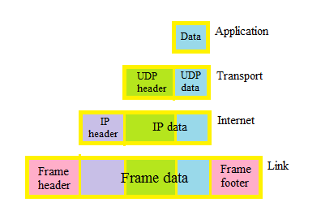
Figure 1 - Serial encapsulation of data through TCP / IP protocol stack to transfer over the network

    - The FTP protocol and telnet protocol

The FTP (File Transfer Protocol) intended for the exchange of binary and text files between the client and FTP protocol server. Setting a connection with the remote computer, the user can copy a file from a remote computer on your own, or copy a file from your computer on your remote. The FTP protocol is using TCP as transport (port 21, 20).
In reviewing FTP as the Internet service have in mind not just the protocol, namely service - access to files that are on the appropriate file server.
In the modern operating systems is a standard program to support the client of the FTP protocol. Its purpose is to transfer files between computers that run in TCP / IP networks: on one of the computers running server software, on the other - client software that runs by user, which connects to the server and transmits or receives files through the FTP-service. This is considered with the assumption that the user has an account on the server and uses the username and password on this computer, or server allows anonymous connections.
Telnet (TErminaL NETwork) is the application protocol intended to implement a remote command line interface over a network (over TCP transport protocol). The name «telnet» are also some tools that implement the client part of the protocol.

    - The UDP protocol

The UDP (User Datagram Protocol) is one of TCP/IP stack protocols. Its difference with TCP is that UDP is working without connection. UDP is one of the simplest protocols of transport layer model OSI, which performs datagram exchange without confirmation and guarantee delivery. Using the UDP processing and retransmission lost datagram is performed protocol higher (application) level. But despite of this, UDP protocol is effective for transmitting multimedia data and short messages.
UDP protocol is used by default such services and higher level protocols:
- TFTP - Trivial File Transfer Protocol
- SNMP - Simple Network Management Protocol
- DNS - Domain Name System.

    - TTL field in IP-header

TTL (Time to live) is the greatest number of routers ("hops"), which can process IP packet. Each router decreases this field by 1, and if it is equal to 0, the IP packet is destroyed, and for its sender sent the appropriate ICMP message. In IPv4 TTL is an 8 bits field in IP-header that is, can take the value 0…255. Different operating systems have their TTL values ​​as default, such as Linux-based systems has TTL as default - 64, in Microsoft Windows - 128, Cisco - 255.

    - The port numbers

20, 21 (fcp) – FTP
22 (tcp) – SSH
23 (tcp, udp) – TELNET
25 (tcp) – SMTP
53 (udp) –DNS
69 (udp) - TFTP (спрощений варіант FTP)
80 (tcp, udp) – HTTP
110 (tcp) – POP3
443 (tcp) – HTTPS
445 (udp) – CIFS (Microsoft-DS SMB file sharing)

  - Description of laboratory setup

Laboratory work is done on workstations (PCs) running operating systems (OS) Linux (Slackware, or Ubuntu) and Windows (XP/7/8) in a computer network. One of these operating systems can be installed on a virtual machine on a host computer running a different OS from directly connected (bridged) network cards.
In the Windows OS installed network analyzer (sniffer) Wireshark.

  - Practical advice on setting up software

    - Set up network parameters (IP address and MAC address) for Linux
IP-address for the Linux-system must be issued by teacher, conducting laboratory work. MAC-address must be unique on the local network and selected team itself. Choose random value for MAC address for your Linux of the following form: 00:0x:xx:xx:xx:xx, where x – is hexadecimal digit (from ‘0’ to ‘9’ and from ‘A’ to ‘F’). For example, let it be 00:01:23:45:ab:cd
ifconfig eth0 down
ifconfig eth0 hw ether 00:01:23:45:ab:cd
ifconfig eth0 10.23.30.84 up
ifconfig

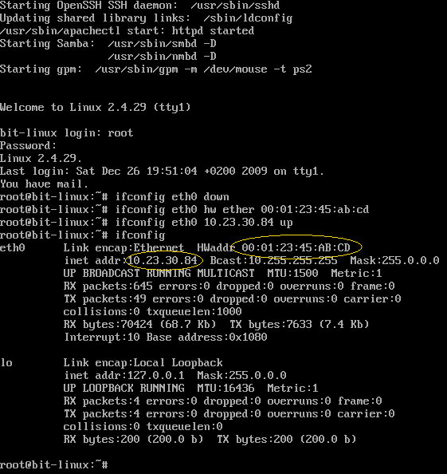

Figure 2 - Linux after setting up your MAC and IP addresses

    - Set of WireShark filters

After that you should see WireShark (fig.3)

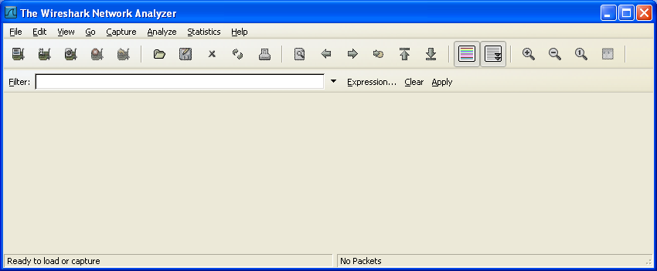

Figure 3 – WireShark window

After that choose the ‘Capture’ menu and the ‘Interfaces’ item inside it. The following dialog box should appear (fig.4):
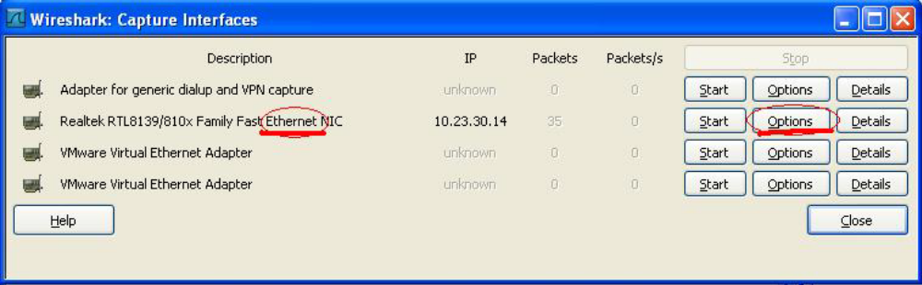
Figure 4 – Choosing network interfaces for sniffing in WireShark

In the next window (fig.5) just press ‘Start’ button to capture several IP packets, then stop the sniffer by pressing the stop button.

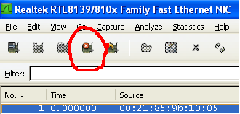
Figure 5 – Stopping sniffing inWireShark

This window consists of three parts (fig.6)
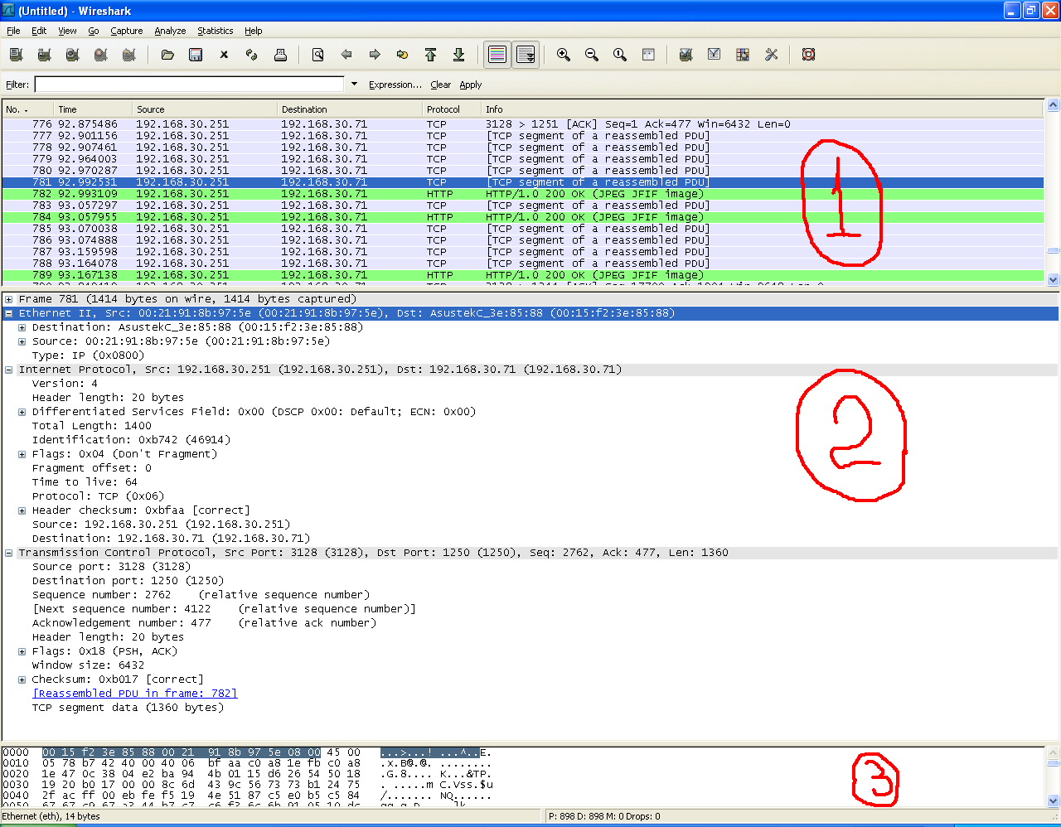
Figure 6 - Captured IP packets in WireShark

1 – list of captured IP packets
2 - Decoded MAC, IP, TCP header in the current batch of 1
3 - Binary representation of the current batch in paragraph 1.

Open window of parameters captured traffic, 'Capture'> 'Interfaces'. Then set the filter for captured traffic by IP address in the box 'Capture Filter': host 10.23.30.84

1.6 Execution order of laboratory work

1.6.1 Login name and password retrieval

First of all you need to get an admission to the lab from the teacher who conducts laboratory work. After this, student receives an account name and password to enter the operating systems Linux and Windows, and also IP-addresses.

1.6.2 Testing and configuring network settings of the OS’s

After registration in the OS you need verify network interfaces: IP address of the computer, the default gateway and the connection with other computers.
In the Linux operating system you should use utilities ifconfig, route and ping, and also ipconfig, route and ping for Windows (typing them in the windows command line).
To access help about the utilities’ keys in Linux you should use instructions (man utility_name) and built-in utility’s help (utility_name -h) in Windows.

1.6.3 Preparing your own networking server in virtual computer

Start the program “VMWare player”, and open there the virtual computer “Linux-BIT”. In the case of absence you need to copy the appliance from a network server (path is specified by teacher).
Start operating system. To switch to Linux inside VMWare just use a mouse click on VMWare window, for returning to Windows XP – press CTRL+ALT.

Log on inside Linux:
login name: root
password: 1

Now you need to set up your network parameters (IP address and MAC address) for Linux (see 1.5.1).

On the next step, check connection between your Windows and Linux computer.
First, ping your Linux from the Windows command line.

ping 10.23.30.84 (substitute with your IP of your own Linux).

After that, check protocols telnet, ftp and http.

telnet 10.23.30.84

login name: user
password: 1
exit

For checking ftp connection with your Linux server type the following in the windows command line:

ftp 10.23.30.84
user name: user
password: 1
quit

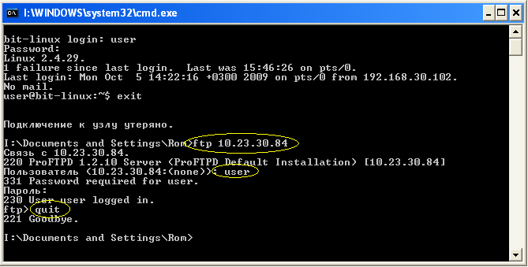
Figure 7 – ftp session from Windows command line

For checking http connection with your Linux server run browser in Windows XP, it can be Internet Explorer, Mozilla Firefox or other.

http://10.23.30.84

Now you have finished setting up your networking Linux server.

1.6.4 Starting WireShark

Use sniffer to analyze traffic with captured package aimed from Linux to Windows machines and vice versa. Instructions of usage WireShark see in 1.5.2.

1.6.5 Researching IP protocol: IP addresses, TTL field via ping and tracert

Check the connection between a Windows computer and virtual machine running the Linux using ping. Then check the connection between two Windows-computers.
Find the difference in value of TTL between OS’s Linux and Windows.
Capture traffic formed by ping in the WireShark and look for a TTL- field in the IP packet (fig. 8):

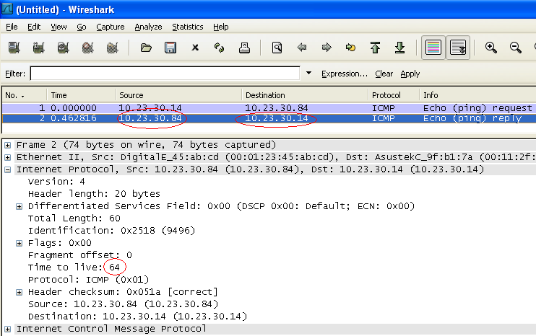
Figure 8 – Captured traffic (ping)

1.6.6 Fragmentation of the IP packet

For the formation of fragmented IP packets use ping, specifying size data block larger than the MTU (4000 bytes; see more in ping manual).
Capture traffic to a remote system, which was formed by ping. Analyze the fragment offset, identification and fragmentation bits.
Then, using the ping utility try to set an IP packet with prohibit fragmentation bit. Capture traffic and analyze the relevant flag in IP header.
Using the ping utility with parameter prohibit fragmentation of IP packets specify MTU for local area network (resize blocks of data). In the calculation take a note of the size of the IP header (20 bytes) and ICMP header (8 bytes).

1.6.7 Researching arp protocol

Capture arp-request and arp-response using sniffer. Pay attention to broadcast and unicast of the relevant packages.
Generate such a request (using ping utility) yourself, if necessary.
Check for the new entry in arp-cache (arp -a in Windows or arp -n in Linux), and look to the lifetime of the entry (up to several minutes in the absence of interaction with the remote host).

1.6.8 Researching UDP header

To view the UDP header field select the appropriate filter and type the following command in Windows command line:

ping google.com.ua
(for any site)

Stop the traffic and look at the DNS request, which is encapsulated in UDP packets.

1.6.9 Establishing and finishing TCP-connections

Open sniffer to set filter parameters for traffic capturing, and enter there the filter value from/to your Linux IP-address and TCP-port 80, for example:

host 10.23.30.84 and tcp port 80

Turn on the sniffer and make HTTP request to the Linux computer with Windows browser. Now you captured a full TCP session between your browser and Linux web-server (Fig.9).
Find 3-way handshake (SYN, SYN + ACK, ACK) and the conclusion of the TCP session (FIN or RST).

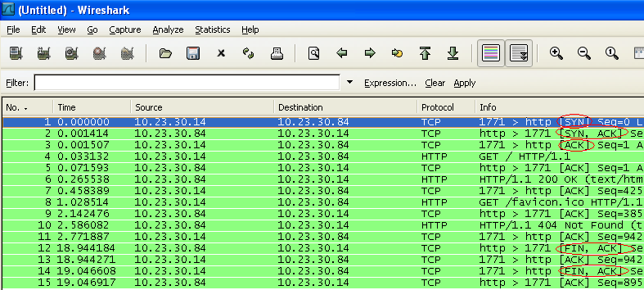
Figure 9 – Captured TCP sessions in Wireshark

1.6.10 Catching passwords in ftp and telnet protocols

Adjust the filter to capture FTP traffic. Install the FTP-connection from OS Windows (command ftp.exe) to OS Linux and use the sniffer to analyze network traffic from the start to conclusion of the session.

1.6.11 Catching HTTP protocol traffic

Adjust the sniffer filter for HTTP traffic. Download Linux-server Web-page from Windows browser (in the browser address bar type http://192.168.100.231, where 192.168.100.231 – IP address of your Linux-computer).
Likewise to the previous paragraph, capture HTTP traffic. Find the original HTML-code of Web-page.
If you see message “Not modified” in the captured traffic (browser checks whether a copy of the page on the server and its cache instead of downloading) change page in Linux-computer. Run mc in Linux command line and edit index.html in the directory /var/www/htdocs/ (editing in mc – key F4, save changes – F2). Then restart sniffer with filter for HTTP traffic and restart your browser on a Windows-computer.

1.6.12 Analysis of SSH protocol traffic

Adjust the sniffer filter for SSH protocol. In Windows run the SSH client putty.exe (program is not standard for Windows, it’s located on a network server).
Similarly to 1.6.8 capture SSH traffic. Find the package, which begins with encrypted traffic.

1.6.13 Using a command line sniffer tcpdump

See manual page for the Linux network analyzer tcpdump (type “man tcpdump” in command line). Manual navigation – keys "up" and "down", quit – “q”, search – “/” and “Enter”, next entry of the template – ‘”n”.
To view manual page and input commands simultaneously use different consoles (switching between them – press two keys Alt-F1, Alt-F2, ... Alt-F6).
Using tcpdump capture ping traffic and the original HTML-code of Web-page, when it’s loading from the Linux-server to the Windows browser.

1.7 Content of the report

At the end of the laboratory work you must make a report which shall contain:
- title page;
- the purpose of work;
- description of the basic functions of network analyzers Wireshark and tcpdump;
- network configurations of computers which were used in this lab (IP- and MAC-address of Windows and Linux);
- copy of information printed by ping utility for computers with different operating systems;
- filter adjustments for capturing http, telnet, ftp and ssh traffic;
- determined MTU value for LAN and ping response during the investigation of this parameter;
- records from the arp-cache;
- copies of WireShark windows, which demonstrate:
    - execution of tracert;
    - arp-request and arp-response;
    - fragmented IP packets and comments to the appropriate header fields;
    - UDP-header;
    - establishment and conclusion of the TCP-connection (desirable 2 different versions);
    - IP packet containing the original HTML-code of the Web-page;
    - example of captured IP packets with attached TCP-header and specified flag PSH in it;
    - captured ftp and telnet passwords;
    - SSH traffic;
- conclusions of the work (datagram transfer, the difference in tcp and udp protocols transmission, especially the transmission of passwords by different application layer protocols, the conclusions quality and verbosity of the report affect the amount of points for a passed laboratory work).

1.8. Control questions and tasks

1. What are the main functions of network analyzers?
2. The main advantages and disadvantages of a network analyzer Wireshark.
3. The main advantages and disadvantages of a network analyzer tcpdump.
4. Compare Wireshark and tcpdump. Determine when it would be better to use a particular analyzer.
5. Compare the captured telnet and ssh sessions traffic. Make your own conclusions.
6. Purpose of packet filtering in the analyzer.
7. Specifics of using protocol analyzer in switches-based networks.
8. 7th-level model OSI, the purposes of each level, 4 levels of TCP/IP stack.
9. What are the default ttl for each type of OS?
10. Purpose of IP-and MAC-addresses, port numbers in TCP and UDP.
11. Reserved port numbers, the purposes of each port.
12. Functions of arp protocol, purpose of arp-cache.
13. Purpose of fragmentation, appropriate fields IP header;
14. Other fields IP-header, their purpose.
15. Specifics in passwords transfer by telnet and ftp protocols.
16. Give the examples of methods for detection a remote operating system type.
17. TTL field in IP-header, its main purpose.
18. The principle of 'tracert', unreliable determination of the way.
19. The default TTL value for different operating systems (remote OS type determination using ping).

